# **Setup a DHCP Server**

## **Description:**

DHCP (Dynamic Host Configuration Protocol) is a network management protocol that automatically assigns IP addresses to devices on a network. It also provides other network configuration information, such as subnet masks and default gateways. This process eliminates the need for manual IP address assignment, simplifying network administration and making it easier to manage devices connecting and disconnecting from the network.

## **Procedure:**

From this project, I designed a simple network using four PCs one switch using the Cisco Packet Tracer. Then, added a server and enabled DHCP feature.

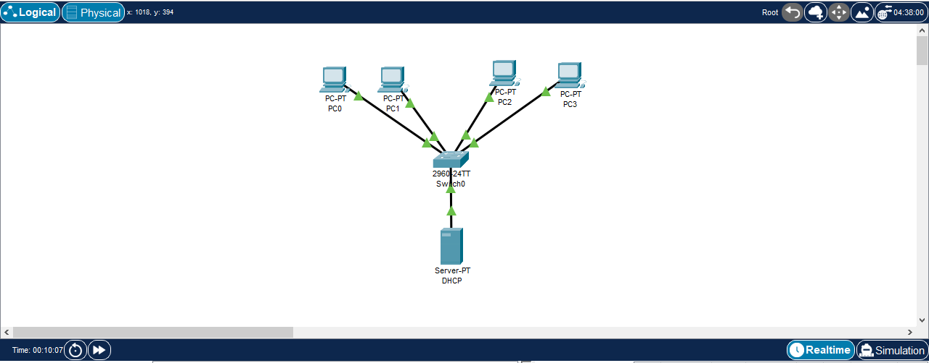

### Figure 1: Designed Network in Packet Tracer

After that, gave a static IP address to the DHCP server. It can be do by following steps.

1. Click on the Server and then display the Device Configuration Window (Figure 2).
2. Then click the Desktop tab -> IP Configuration
3. Choose Static as the IP configuration and give any kind of IP.
4. Click Close icon to exit.

In my setup, I entered 192.168.1.1 to IPv4 address. The final step is setup the automatic IP assign process of each PC. It could do by clicking a PC icon (e.g., PC0) in the design -> click Desktop -> IP Configuration -> DHCP (Figure 3). After doing this process for all PCs, all of configurations finished.

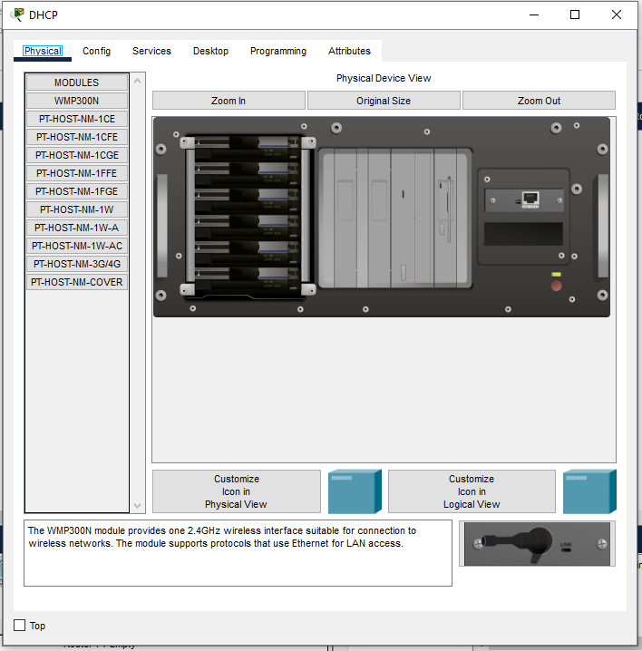

### Figure 2: DHCP Configuration Window

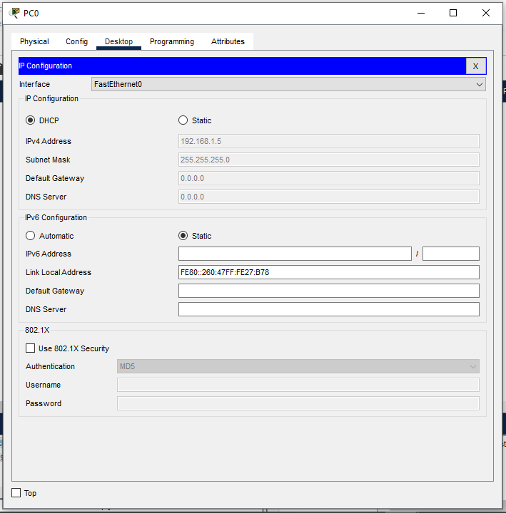

### Figure 3: IP configuration in PC0

**Testing:**

To test the connectivity of each PCs open Command Prompt -> type ping [IP_address] in one PC. If it is ping successfully to the typed IP address.

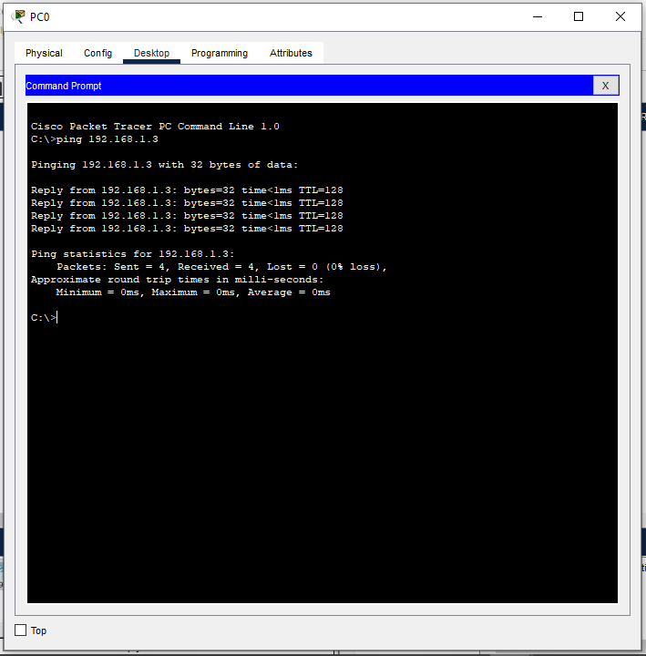

### Figure 4: Ping test from one PC to another PC

## **Learning Outcomes:**

* Gained knowledge about DHCP and how it works.
* Gained hands-on experience of configure DHCP server in virtual home lab environment.